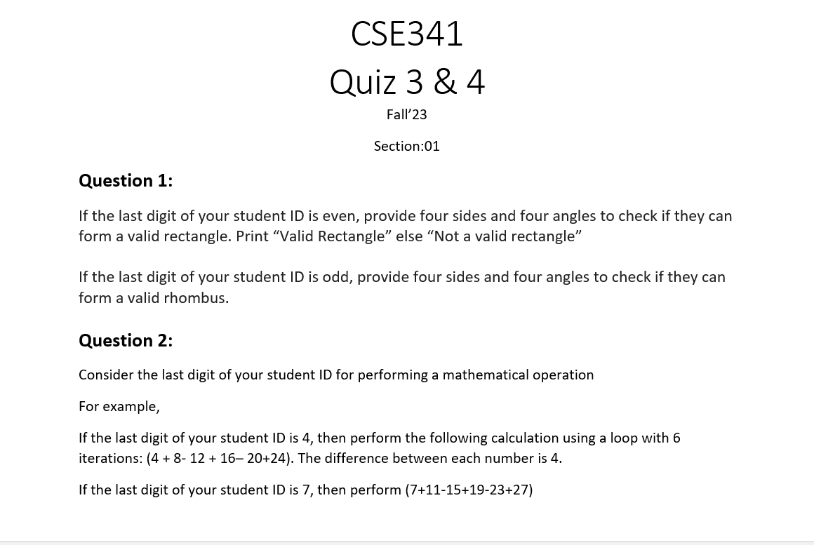
Submission Link: https://docs.google.com/forms/d/e/1FAIpQLSfDkZIvYFTSle6HQCxwKwEcaxCQBhXirYR_fasFSfg6MiPp-g/viewform

